Match: ________
Alliance: Red / Blue
Teams: ____/____/____
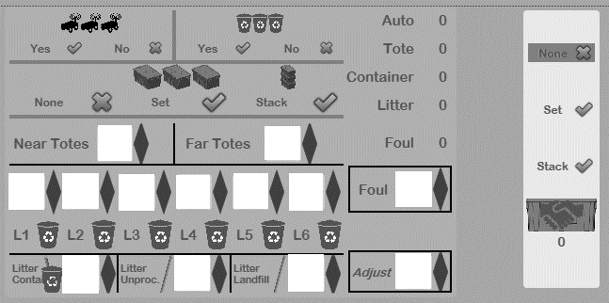

Match: ________
Alliance: Red / Blue
Teams: ____/____/____

